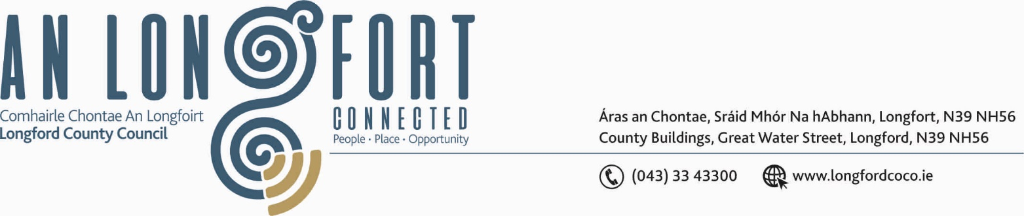

GRANARD MUNICIPAL DISTRICT

Corporate Affairs,
Aras an Chontae,
LONGFOIRT.

22nd January 2020.

To: Each Member of Granard Municipal District.

Dear Member,

You are requested to attend Meeting of Granard Municipal District to be held in
Granard Community Library on Tuesday, 28th January 2020 at 3.00 p.m. to transact business, as set out on the Agenda hereunder.

Yours sincerely,


_______________
Anne Lee,
Meetings Administrator.

AGENDA

Prayer before meeting.

1. Confirmation of Minutes of Municipal District Meetings held on the
4th December 2019 - copy enclosed

2. Matters arising from Minutes.

3. Declaration of Interest by Members.

4. Area Engineer’s Progress Report.

5. Update on Granard Public Art Features.

6. Consideration and adoption of Draft Municipal District Report for inclusion in
Longford County Council 2019 Annual Report – enclosed.

7. Notices of Motions, submitted by Councillors, as listed hereunder –

Councillor Turlough McGovern.

“It has been brought to my attention that the lighting on the
Granard /Longford Road, R194, on the right side is inadequate (poor visibility for walking and potential accidents on the footpaths )from
The Pat Baker Yard to Pettit Yard.”

“Concerned residents have raised concerns to me regarding a potential accident black spot at Springtown, R194. I would like to propose a suitable solution to this e.g. take out the bend or more enhanced visible signage/rumble strips as a safety measure.”

8. A.O.B.



